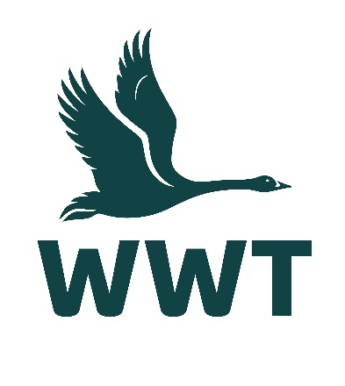
______________________________________________________________

VOLUNTEER OPPORTUNITY: Office Administration Volunteer
______________________________________________________________

About the role
Volunteers are integral to the running of our beautiful WWT Arundel Wetland Centre, an award-winning site for accessible and inclusive tourism. Our volunteer team is friendly, motivated, and hard-working, and benefit from gaining new experiences, meeting new people, and making a difference by helping maintain our important wetland habitat.
In this role, you’ll be supporting our Marketing, Learning, and Facilities teams to stay on top of day-to-day essentials and keep organized behind the scenes. Responsibilities will include compiling the information we use to inspire visitors to support wetlands, responding quickly to supporter queries, and helping to provide information online to encourage visitors to support us and connect with nature.
If you enjoy an office environment where you can focus on detailed work, self-led tasks, and computer databases, then this is the role for you! Alongside this, you will have the opportunity to meet new like-minded colleagues and enjoy our beautiful outdoor reserve.
Volunteers are an essential part of the WWT team, and we wouldn’t be able to maintain our internationally important wetland sites without their help. You will receive a very warm welcome, full induction & training, and be provided with any necessary equipment, uniforms, and anything else needed to thrive in your role.

Main tasks
- Updating databases and external event websites
- Organising digital and physical files
- Preparing materials for events and corporate functions
- Processing ticket requests from schools and charities
- Keeping up-to-date with WWT news and conservation work
- Responding to supporter and visitor queries
- Helping with ad-hoc related activities

Role practicalities
Location: | WWT Arundel
Manager: | Marketing & Communications Manager
Days: | We are looking for volunteers who are available to help out one day a fortnight for 3 hours. For your induction, we may ask you to attend a training session over the weekend.
Time commitment: | To ensure a positive volunteering experience for you and to provide a helpful contribution to the organisation, we hope you will be able to volunteer with for us for at least six months.
Age restrictions: | This role is not suitable for people under 18 years.
Additional notes: | This is an unpaid voluntary position. Unfortunately, WWT are not currently able to reimburse travel expenses for volunteers.

About you
No previous experience is required for this role as full training will be provided, and a willingness to learn new skills is more important.
This role would suit you if:
- You would enjoy a behind-the-scenes role working in a busy office
- You are highly organised and have good attention to detail
- You enjoy working as part of a team of staff and volunteers
- You can work independently using your own initiative and are self-motivated
- You have an interest in and enthusiasm for the work of WWT
- You have excellent written and verbal communication skills
- You are IT-literate and have a good working knowledge of using Microsoft Office and Microsoft Teams

About us
We are WWT, and we’re on a mission to restore the super-powered ecosystems we call wetlands. There’s never been a more important moment for our work, and we’ve got some phenomenal people on the case.
Whether you’re looking to meet new people, learn new skills or spend time in our wildlife-rich wetlands, there’s a volunteer role for you. Just a few hours spent volunteering can really make a world of difference to our wildlife, and to you.
So, come surround yourself with the wonder of wetlands, and the people who inject their energy and passion into them. Whatever you do here, you’ll be helping to restore wetlands and unlock their power. The only question left is, what role will you play?

Why you’ll love volunteering at WWT
- Make a real contribution to the conservation and engagement work of WWT
- Work at one of our beautiful and internationally important wetland sites
- Be surrounded and inspired by like-minded nature lovers who bring energy, passion, and expertise to their role
- Make new friends and become part of a friendly and inclusive community
- Gain volunteering experience and learn & develop new skills
- Get volunteer discounts for WWT shops, café, and membership
- Get free entry to all our UK wetland centres, including for your family
- Receive access to wildlife talks, webinars, and practical information to help you manage your volunteer role & daily life
- Be kept informed about what’s happening in our organisation and the positive change you are helping to make happen

Interested in applying?
Please apply for this volunteer role via our website - we look forward to receiving your application!
We celebrate inclusivity and diversity amongst our volunteering community and actively welcome applications from individuals of all backgrounds. If you have a disability or think you may need additional support to carry out a volunteering role, please state the relevant details on your application form so that we can support you with your volunteering experience.
If you are unable to apply online via our website, please email volunteering@wwt.org.uk for further assistance.

