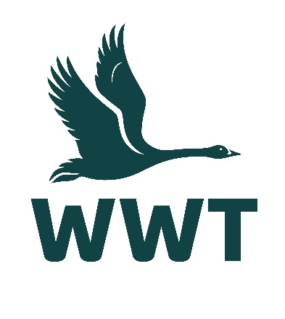
______________________________________________________________

VOLUNTEER OPPORTUNITY: Image Library Volunteer
______________________________________________________________

About the role
At WWT, we believe that the best way for people to understand and connect to wetlands is to experience them, so we bring awe-inspiring nature up close and let it do the talking. Imagery is a central part of connecting our supporters to the work we do.
We are looking for an Image Library Volunteer to help us manage our thousands of engaging and inspiring images, capturing our events and activities, people, wildlife, and visitor experiences. These images are used in our promotional materials including website, press releases, staff & volunteer booklets, social media, and news articles.
​You will be selecting the most inspiring and engaging images, uploading them to our Image Library, tagging images to facilitate user searches, and regularly reviewing uploaded material. This is an important role in helping to keep our image database updated, on-brand, and easily accessible as a vital resource for staff across WWT.
Volunteers are an essential part of the WWT team, and we wouldn’t be able to maintain our internationally important wetland sites without their help. You will receive a very warm welcome, full induction & training, and be provided with any necessary equipment, uniforms, and anything else needed to thrive in your role.

Main tasks
- Processing image and video files captured by our volunteers and staff
- Selecting files according to image quality (sharpness, focus, exposure, background, composition) and engaging subject matter
- Uploading the selected files to the WWT Image Library
- Using our established system of image tagging and metadata, facilitating users to be able to search the library for images
- Regularly reviewing uploaded material and archiving media when it is out-of-date, off-brand, or no longer relevant

Role practicalities
Location: | WWT Slimbridge (Central Office)
Manager: | Brand & Content Team
Days: | We are looking for volunteers who are available to help out a minimum of a few hours a month, but more if you wish! We ask that volunteers come into the Slimbridge office rather than working remotely – flexible times/days to be agreed.
Time commitment: | To ensure a positive volunteering experience for you and to provide a helpful contribution to the organisation, we hope you will be able to volunteer with for us for at least six months.
Age restrictions: | This role is not suitable for people under 18 years.
Additional notes: | This is an unpaid voluntary position. Unfortunately, WWT are not currently able to reimburse travel expenses for volunteers.

About you
No previous experience is required for this role as full training will be provided, and a willingness to learn new skills is more important.
This role would suit you if:
- You have a keen eye for interesting photographs with a good composition
- You are confident in making decisions on the suitability and marketability of images
- You have a good standard of IT literacy
- You have prior experience using Adobe Lightroom (training will be provided)
- You have a basic knowledge of wetland species – you will need to be able to carry out research to accurately identify species in the images
- You are highly organised and have good attention to detail
- You can work independently using your own initiative and are self-motivated

About us
We are WWT, and we’re on a mission to restore the super-powered ecosystems we call wetlands. There’s never been a more important moment for our work, and we’ve got some phenomenal people on the case.
Whether you’re looking to meet new people, learn new skills or spend time in our wildlife-rich wetlands, there’s a volunteer role for you. Just a few hours spent volunteering can really make a world of difference to our wildlife, and to you.
So, come surround yourself with the wonder of wetlands, and the people who inject their energy and passion into them. Whatever you do here, you’ll be helping to restore wetlands and unlock their power. The only question left is, what role will you play?

Why you’ll love volunteering at WWT
- Make a real contribution to the conservation and engagement work of WWT
- Work at one of our beautiful and internationally important wetland sites
- Be surrounded and inspired by like-minded nature lovers who bring energy, passion, and expertise to their role
- Make new friends and become part of a friendly and inclusive community
- Gain volunteering experience and learn & develop new skills
- Get volunteer discounts for WWT shops, café, and membership
- Get free entry to all our UK wetland centres, including for your family
- Receive access to wildlife talks, webinars, and practical information to help you manage your volunteer role & daily life
- Be kept informed about what’s happening in our organisation and the positive change you are helping to make happen

Interested in applying?
Please apply for this volunteer role via our website - we look forward to receiving your application!
We celebrate inclusivity and diversity amongst our volunteering community and actively welcome applications from individuals of all backgrounds. If you have a disability or think you may need additional support to carry out a volunteering role, please state the relevant details on your application form so that we can support you with your volunteering experience.
If you are unable to apply online via our website, please email volunteering@wwt.org.uk for further assistance.

