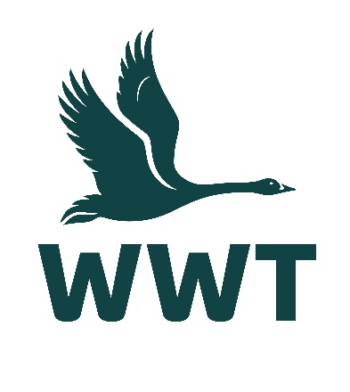
______________________________________________________________

VOLUNTEER OPPORTUNITY: Volunteer Toddler Activities Assistant
(Term Time)
______________________________________________________________

About the role
At WWT, we believe that the best way for people to understand and connect to wetlands is to experience them first hand, so we bring awe-inspiring nature up close. We create unforgettable experiences for young people through our warm welcome, positive interactions, and fun engaging activities.
We are looking for keen and enthusiastic volunteers to help run our weekly Wednesday term-time toddler group called “The Gosling Gang”! You will be working with other volunteers and staff to ensure families and young children visiting our centre feel part of something amazing.
Volunteers are an essential part of the WWT team, and we wouldn’t be able to maintain our internationally important wetland sites without their help. You will receive a very warm welcome, full induction & training, and be provided with any necessary equipment, uniforms, and anything else needed to thrive in your role.

Main tasks
- Helping to plan the annual programme of activities and themed events
- Managing the activity area – setting up the area ready for each session, tidying and clearing away at the end of each session
- Assisting with the running of a 45-minute activity session between 10-11am, including story time, sing-alongs, crafting, and outdoor activities (weather-dependent)
- Helping prepare craft activities for future sessions
- Assisting with visual wall displays in the designated “Gosling Gang” room

Role practicalities
Location: | WWT Martin Mere
Manager: | Visitor Experience Team
Days: | We are looking for volunteers who are available to help out on Wednesdays, but are open to running additional days if we get sufficient volunteers
Time commitment: | To ensure a positive volunteering experience for you and to provide a helpful contribution to the organisation, we hope you will be able to volunteer with for us for at least six months.
Age restrictions: | This role is not suitable for people under 18 years.
Additional notes: | This is an unpaid voluntary position. Unfortunately, WWT are not currently able to reimburse travel expenses for volunteers.

About you
No previous experience is required for this role as full training will be provided, and a willingness to learn new skills is more important.
This role would suit you if:
- You have previous experience in an educational setting or running similar groups, particularly with toddler-aged children
- You have excellent verbal communication skills
- You feel confident in talking to and engaging with young people
- You can adapt your communication style to suit your audience
- You are friendly and approachable with a positive attitude
- You have an interest in and enthusiasm for the work of WWT
- You enjoy working as part of a team of staff and volunteers

About us
We are WWT, and we’re on a mission to restore the super-powered ecosystems we call wetlands. There’s never been a more important moment for our work, and we’ve got some phenomenal people on the case.
Whether you’re looking to meet new people, learn new skills or spend time in our wildlife-rich wetlands, there’s a volunteer role for you. Just a few hours spent volunteering can really make a world of difference to our wildlife, and to you.
So, come surround yourself with the wonder of wetlands, and the people who inject their energy and passion into them. Whatever you do here, you’ll be helping to restore wetlands and unlock their power. The only question left is, what role will you play?

Why you’ll love volunteering at WWT
- Make a real contribution to the conservation and engagement work of WWT
- Work at one of our beautiful and internationally important wetland sites
- Be surrounded and inspired by like-minded nature lovers who bring energy, passion, and expertise to their role
- Make new friends and become part of a friendly and inclusive community
- Gain volunteering experience and learn & develop new skills
- Get volunteer discounts for WWT shops, café, and membership
- Get free entry to all our UK wetland centres, including for your family
- Receive access to wildlife talks, webinars, and practical information to help you manage your volunteer role & daily life
- Be kept informed about what’s happening in our organisation and the positive change you are helping to make happen

Interested in applying?
Please apply for this volunteer role via our website - we look forward to receiving your application!
We celebrate inclusivity and diversity amongst our volunteering community and actively welcome applications from individuals of all backgrounds. If you have a disability or think you may need additional support to carry out a volunteering role, please state the relevant details on your application form so that we can support you with your volunteering experience.
If you are unable to apply online via our website, please email volunteering@wwt.org.uk for further assistance.

