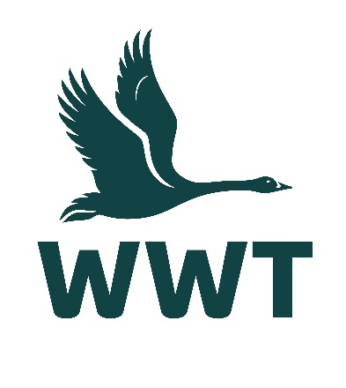
______________________________________________________________

VOLUNTEER OPPORTUNITY: Catering Volunteer
______________________________________________________________

About the role
At WWT we shape unforgettable experiences, and at our heart we are warm, welcoming, and genuine. We want to ensure that our visitors receive a friendly welcome and have a comfortable and enjoyable visit.
Our Waterside café offers a delicious selection of home-cooked food, tray bakes, light snacks, and hot or chilled beverages, served by our friendly team of staff and volunteers. We are looking for volunteers who can provide hands-on support to our café team, ensuring we offer excellent customer service to all our visitors.
Volunteers are an essential part of the WWT team, and we wouldn’t be able to maintain our internationally important wetland sites without their help. You will receive a very warm welcome, full induction & training, and be provided with the necessary equipment, uniform, and anything else needed to thrive in your role.

Main tasks
- Serving food, snacks, and drinks to visitors
- Assisting with café team with tidying, clearing, and cleaning tables
- Supporting behind-the-scenes with washing up, dishwasher loading, and sorting deliveries
- Engaging with café visitors and helping with any queries they may have
- Assisting with recycling and waste disposal
- Refilling food counters and displays to ensure they are replenished and look tempting
- Directing customers to available tables during busy periods

Role practicalities
Location: | WWT Washington
Manager: | Catering Supervisor
Days: | We are looking for volunteers who are available to help out one day a week from 11-3pm. Assistance on weekends and during school holidays is especially welcome.
Time commitment: | To ensure a positive volunteering experience for you and to provide a helpful contribution to the organisation, we hope you will be able to volunteer with for us for at least six months.
Age restrictions: | This role is not suitable for people under 18 years.
Additional notes: | This is an unpaid voluntary position. Unfortunately, WWT are not currently able to reimburse travel expenses for volunteers.

About you
No previous experience is required for this role as full training will be provided, and a willingness to learn new skills is more important.
This role would suit you if:
- You have an enthusiastic and friendly manner
- You have good verbal communication skills
- You enjoy working as part of a team of staff and volunteers
- You have a strong commitment to excellent customer service
- Have previous experience working in hospitality
- You maintain excellent standards of food safety and personal hygiene
- You have a good level of physical fitness - this role involves spending periods of time on your feet and may include some light lifting or carrying

About us
We are WWT, and we’re on a mission to restore the super-powered ecosystems we call wetlands. There’s never been a more important moment for our work, and we’ve got some phenomenal people on the case.
Whether you’re looking to meet new people, learn new skills or spend time in our wildlife-rich wetlands, there’s a volunteer role for you. Just a few hours spent volunteering can really make a world of difference to our wildlife, and to you.
So, come surround yourself with the wonder of wetlands, and the people who inject their energy and passion into them. Whatever you do here, you’ll be helping to restore wetlands and unlock their power. The only question left is, what role will you play?

Why you’ll love volunteering at WWT
- Make a real contribution to the conservation and engagement work of WWT
- Work at one of our beautiful and internationally important wetland sites
- Be surrounded and inspired by like-minded nature lovers who bring energy, passion, and expertise to their role
- Make new friends and become part of a friendly and inclusive community
- Gain volunteering experience and learn & develop new skills
- Get volunteer discounts for WWT shops, café, and membership
- Get free entry to all our UK wetland centres, including for your family
- Receive access to wildlife talks, webinars, and practical information to help you manage your volunteer role & daily life
- Be kept informed about what’s happening in our organisation and the positive change you are helping to make happen

Interested in applying?
Please apply for this volunteer role via our website - we look forward to receiving your application!
We celebrate inclusivity and diversity amongst our volunteering community and actively welcome applications from individuals of all backgrounds. If you have a disability or think you may need additional support to carry out a volunteering role, please state the relevant details on your application form so that we can support you with your volunteering experience.
If you are unable to apply online via our website, please email volunteering@wwt.org.uk for further assistance.

